Project Design Phase-II
Technology Stack (Architecture & Stack)

Date | 31 January 3035
Team ID
Project Name | Startegic Product Placement Analysis
Maximum Marks | 4 Marks

Technical Architecture:
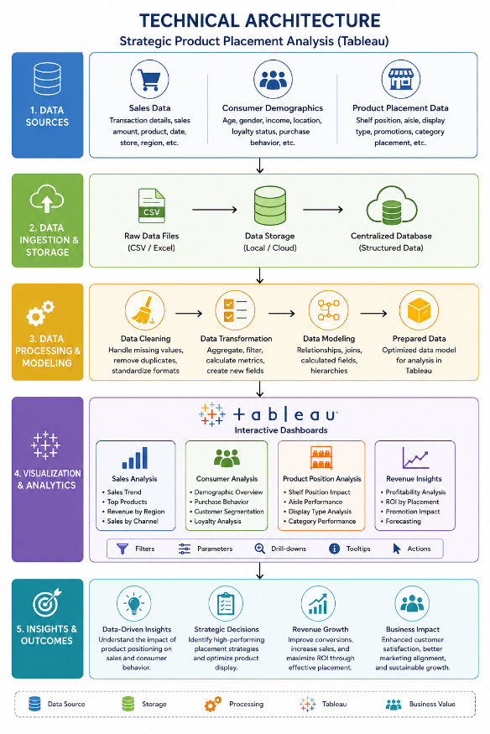

Table-1 : Components & Technologies:
S.No | Component | Description | Technology
1 | User Interface | Interactive dashboards for users to view and analyze data | Tableau Dashboard
2 | Application Logic-1 | Data preprocessing and cleaning logic | Tableau
3 | Application Logic-2 | Data transformation and integration logic | Tableau Dashboard
4 | Application Logic-3 | Data analysis and visualization logic | Tableau
5 | Database | Stores structured sales, product, and customer data | N/A
6 | Cloud Database | Cloud-based storage for scalable data handling | N/A
7 | File Storage | Stores datasets and exported reports | Local File System / Cloud Storage (AWS S3)
8 | External API-1 | Data import from external retail or analytics sources | Retail APIs / CSV Data Sources
9 | External API-2 | Optional integration for demographic or market data | N/A
10 | Machine Learning Model | Predict trends and customer behavior patterns | N/A
11 | Infrastructure (Server / Cloud) | Deployment and hosting environment | Local System / AWS / Azure

Table-2: Application Characteristics:
S.No | Characteristics | Description | Technology
1 | Open-Source Frameworks | Libraries used for data processing and analysis | Python (Pandas, NumPy, Matplotlib)
2 | Security Implementations | Data protection and access control mechanisms | Authentication, Data Encryption
3 | Scalable Architecture | Ability to handle increasing data volume | Cloud-based architecture (AWS, BigQuery)
4 | Availability | Ensures system is accessible when needed | Cloud Hosting with High Availability
5 | Performance | Efficient processing and fast dashboard loading | Tableau Optimization, Indexed Databases

